# Unit 6 Assignment – Technology Innovation – Part 2

# Amon-Ra

# Herzing University

# BU 620-8 Technology and Innovation

**Overview**

Sephora is a multinational company in the beauty and cosmetic industry. The company was established in 1970 in France by Dominique Mandonnaud. The company is one of a few high-end luxury brand business operating the umbrella of Moët Hennessy Louis Vuitton (LVMH). Louise Vuitton is renowned for its fashion while fine wine and high-end spirits are the specialty of Moët Hennessy. LVMH is the result a 1987 merger Louis Vuitton and Moët Hennessy. Recently, Tiffany and Co. was added to the LVMH family, which affords the luxury house to expand to the fine jewelry market. With Sephora LVMH is covering even more ground in the luxury brands market with its beauty and cosmetics.

Along with the acquisition of Sephora comes their innovation in the beauty and cosmetic industry. Customers have had to endure a lack of the proper cosmetic foundation for beautification purposes. Consumers of foundation makeup often are left to settle for products that do not match the skin tone. Imagine the embarrassment of having a facial tone that doesn’t match other portions of the body that are exposed such as the neck, ears, arms and legs. Through technological innovation Sephora has achieved the ability to correctly match foundation to the wearer’s face to create a long sought-after natural look. This innovative technology is called Color IQ.

Color IQ works by conducting a scan of the skin and correlating it with a Color IQ number of 1500 possibilities. The possibilities correspond to 1500 foundation products. The identified number is the foundation cosmetic match that the customer should use for their particular skin tone. Devices that conduct Color IQ scans are found only at Sephora locations. Customers wanting to use the service will need to visit their local Sephora location.

Innovation is a never-ending endeavor. Additional innovation will expand on accessibility and method of use. Color IQ is a truly innovative service and while we believe that the technology is a breakthrough that will bring many to Sephora locations to identify and acquire the correct foundation, we could expand its use by placing it in millions of locations.

Figure 1.

Worldwide Mobile Traffic 2013 - 2018

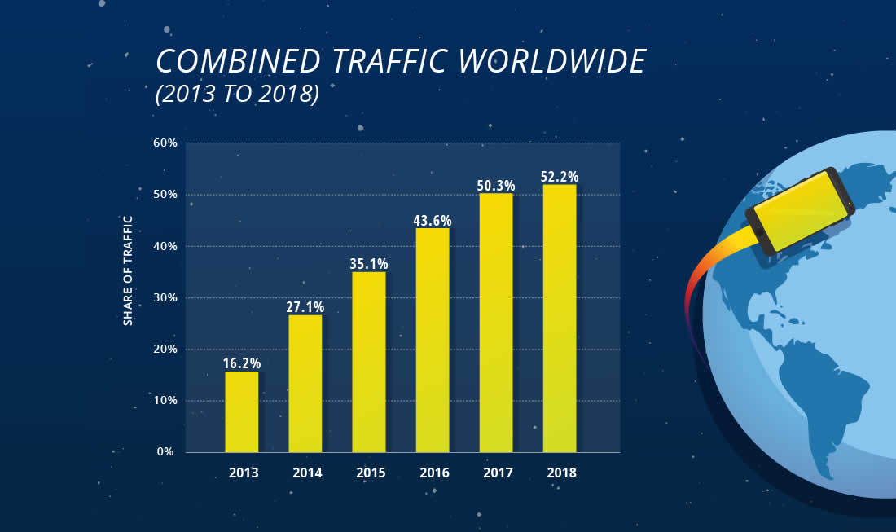

*Note*. Reprinted from Mobile Vs. Desktop Usage (Latest 2019 Data), retrieved from https://www.broadbandsearch.net/blog/mobile-desktop-internet-usage-statistics.

People spend more money on smart phone than personal computers. Thanks to the influential marketing campaign of phone manufacturers, the mobile technology market has grown and continues to grow, figure 1. Such phones have outpaced laptops and are usually more technologically advanced in addition to being everywhere. On average, more people have phones with better cameras, faster CPU, more ram, larger storage space, and a direct connection to the internet. The mobile landscape of information technology presents an opportunity for expansion of Color IQ.

**Specific Characteristics of the Innovation**

Color IQ is going mobile and will make its way to every phone via the creation of the Sephora Color IQ app.

At Sephora locations, a Sephora professional uses a hand held colorimeter to measure the color from three parts of the skin. The measurements are averaged by Color IQ to produce a universal skin tone number. The universal skin tone number is manually transferred from the colorimeter into the Sephora database. The database returns matches from Sephora’s database of 1500 powders, moisturizers, and foundations to match the universal skin tone number.

“Colorimeters take tristimulus readings which give red, green and blue (RGB) values, known as chromacity coordinates, mimicking the way in which the human eye processes visible radiation.” (“The Latest Technology for Colorimetry”, 2016) Readings are taken using three different filters red, green, and blue. The reading defines how much red, green, and blue is detected within a color. Each of the three measurements have a decimal value within the range of 0 to 255. The highest concentration of red, green, and blue is 255. The lower the number, the less concentration of red, blue, or green. The different combinations of the three values create the various shades of colors as seen by the human eye, which are converted to a hexadecimal value, *figure 2.*

Figure 2

RGB Color Wheel

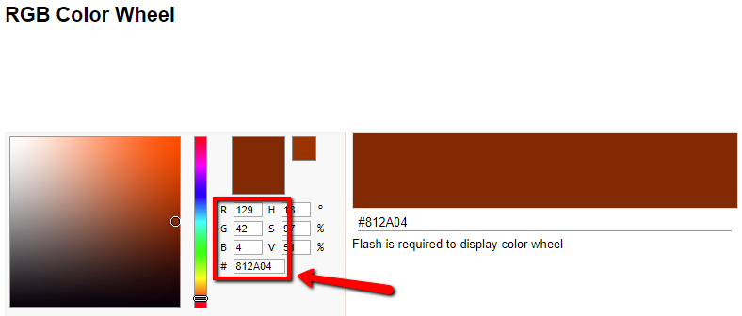

*Note*. Reprinted from RGB Color Wheel, retrieved from https://www.colorspire.com/rgb-color-wheel/

|  |  |
| --- | --- |
| Figure 3  Color Grab App | The user would first sign into their online account and select Color IQ. To emulate the scanning process, I located and downloaded an RGB color scanner app for Google Play store. The app titled Color Grab and is free to use, *figure 3*. The app uses the smart phone’s camera as the scanning input to measure the amount of red, green, and blue. The app slightly differences from Sephora Color IQ in that it takes three measurements, i.e. three scans from three different areas of skin and averages the three to produce the |

Figure 4

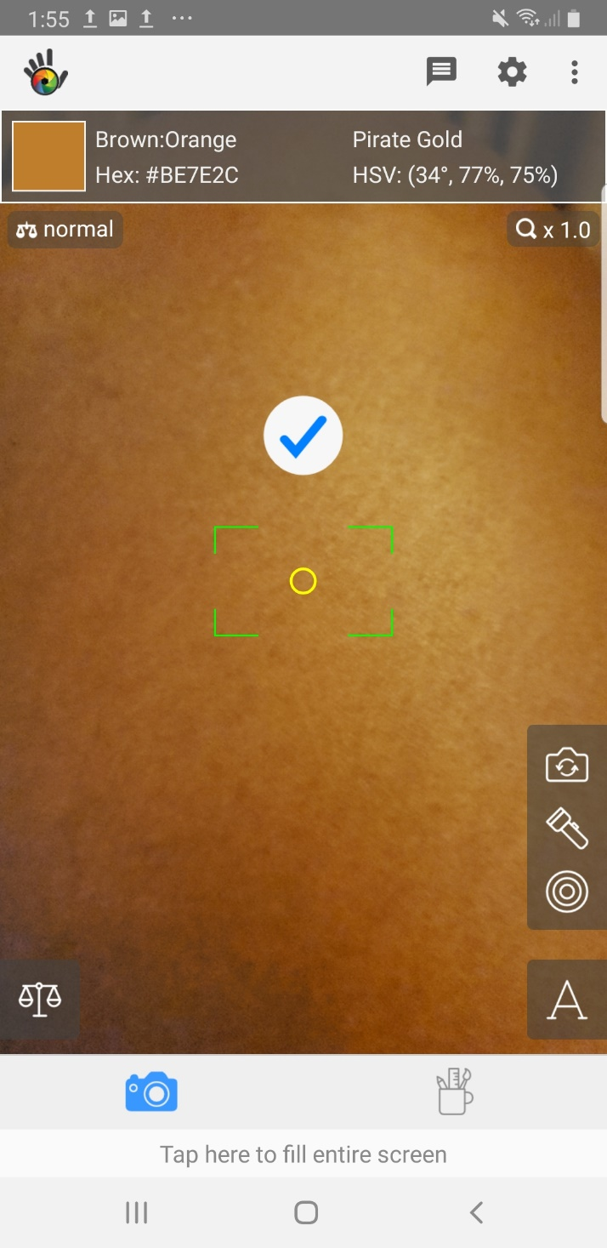Color Grab App Scan

universal skin tone number. The app does not have the built-in feature to take three scans and produce an average that can then be correlated. However, to simulate take three scans and produce an average that can then be correlated. However, to the averaging process, I can take three scans and manually produce the average. Three scans and an average are for the accuracy purposes. For this demonstration, I utilized a single scan in the place of the triple scan and average. Upon scanning the skin, the app produced a color result of Brown:Orange. It also produced a corresponding hexadecimal value of BE7E2C, *figure 4.* This hexadecimal value could be used as the universal skin tone number. The app would save the universal skin tone number to the user account and enter the number into the Sephora database. The customer would then be presented with matching powders, moisturizers, and foundations based on their universal skin tone number. From the matching products, the customer can select any desired products and place their order in from the app. The results will be saved in the users account that can be accessed via the app for future orders and can also be accessed by Sephora professional when the customer makes an in-store visit.

Figure 5

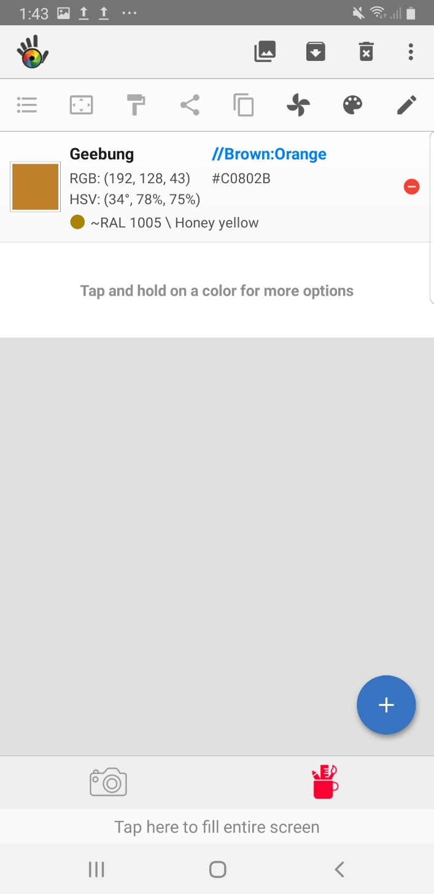Color Grab App Scan

**Steps for Creation/Implementation**

* Hire a third-party app developer.
* Decide which smart phone operating system platforms that the app will support.
* Perform tests against various phones with various camera specifications to discover minimum requirements.
* Enable the app can link to the customer’s account.
* Ensure the universal skin tone number is saved under the user’s account and linked to Sephora’s database of products.
* Product results should be accurate.
* Create the ability to place orders based on product results.

IOS, i.e. Apple and Android have the largest share of the mobile phone market.

* a discussion of the technological challenges that may be encountered
* a discussion of the organizational challenges that may be encountered
* a scorecard that can be used to evaluate the overall success of the innovation

## References:

## About Us. (n.d.). Retrieved December 1, 2019, from https://www.sephora.com/beauty/about-us

## LVMH Reaches Agreement with Tiffany & Co. (n.d.). Retrieved December 4, 2019, from https://www.lvmh.com/news-documents/press-releases/lvmh-reaches-agreement-with-tiffany-co/

## Mobile Vs. Desktop Usage (Latest 2019 Data). (n.d.). Retrieved December 5, 2019, from https://www.broadbandsearch.net/blog/mobile-desktop-internet-usage-statistics.

Reiff, N. (2019, November 18). Top 6 Companies Owned by Louis Vuitton. Retrieved from https://www.investopedia.com/articles/insights/081816/top-7-companies-owned-louis-vuitton-lvmuy.asp

RGB Color Wheel. (n.d.). Retrieved December 5, 2019, from https://www.colorspire.com/rgb-color-wheel/.

The Latest Technology for Colorimetry. (2016, September 9). Retrieved from https://www.azom.com/article.aspx?ArticleID=13160.